April 14, 2022

Senator Sherrod Brown
United States Senate
713 Hart Senate Office Building
Washington, DC 20002

Re: Federal Community Project Funding Appropriation Request
Summit County High Level Bridge, Phase II – Detailed Design

Dear Senator Brown:

The purpose of this letter is to express my strong support and commitment to the County of Summit, Ohio’s application for a Federal Community Project Funding Appropriation Request for the engineering funding for the Summit County High Level Bridge, Phase II Project. The High Level Bridge, also known as the North Main Street Bridge over the Cuyahoga River is in need of replacement within the next 5 years. This structure carries North Main Street over the Cuyahoga River and connects it with State Road on the north side of bridge as it enters Cuyahoga Falls. The current structure was built in 1948, is functionally obsolete, and classified as a “fracture critical” type of bridge. This project ties into previous projects on North Main Street in Akron as well as their current request for funding for improvements along North Main Street Phase I, which includes a new approach to the High Level Bridge. The bridge is on a major route and connects the City of Cuyahoga Falls and the City of Akron, making it critical for commerce and economic activity between the two cities. For the reasons set forth below, I believe the Summit County High Level Bridge request warrants a Federal appropriation.

The current structure was built in 1948 and has a sufficiency rating of 37 out of 100 and general appraisal rating of 5A out of 9. The structure is categorized as fracture critical, meaning if one element of the bridge fails, the entire bridge will fail. Current bridge design standards require structures to have redundancy built in to prevent catastrophic failures like we saw with the I-35W Bridge in Minnesota, which was also a fracture critical bridge. The High Level Bridge is 909 feet long, 67 feet wide, and spans 220 feet above the Cuyahoga River and Metro Parks Serving Summit County’s High Bridge Trail. In addition to the economic importance of keeping the two largest cities in Summit County connected, a safe and open bridge is critical for recreation activity in the area with the bridge being the main feature for hikers and bikers of the Metro Park’s High Bridge Trail.

The new bridge will be constructed alongside the current bridge in order to keep the bridge open throughout construction. The surrounding cities have emphasized the importance of keeping the road open to traffic at all times during construction, so the design engineering and preliminary engineering will have to include additional environmental and right-of-way planning to keep traffic moving between Cuyahoga Falls and Akron. The Summit County Engineer’s office is currently awarding a $400,000.00 preliminary engineering contract for Phase I of the project, which is funded with all local funds.

The Summit County Engineer’s Office is funded through license fees and gas taxes. The annual revenue of the office is approximately $19 million per year. The construction of a new High Level Bridge is estimated to be between $55-$60 million, an estimate that recently increased due to inflation. The planning funding needed is estimated to be $7.9 million total, which is 41% of the Summit County Engineer’s Office annual revenue. The County is also responsible for 280 other bridges and over 360 lanes miles of roadway so getting outside funding for the design and engineering for the High Level Bridge is the only way to move the project forward without neglecting the rest of the County’s road infrastructure. The High Level Bridge must be replaced within the next 10 years otherwise the bridge will have to be closed for safety reasons, cutting off one of the two major routes between Akron and Cuyahoga Falls.

For the reasons set forth in this letter, I strongly support the County of Summit’s application for a Federal Community Project Funding Appropriations Request for the Summit County High Level Bridge, Phase II Project. On behalf of my community, I ask that you submit the same for funding in this year’s appropriations process. Thank you for your time and attention, and please do not hesitate to contact me if you wish to discuss this letter further.

Sincerely,
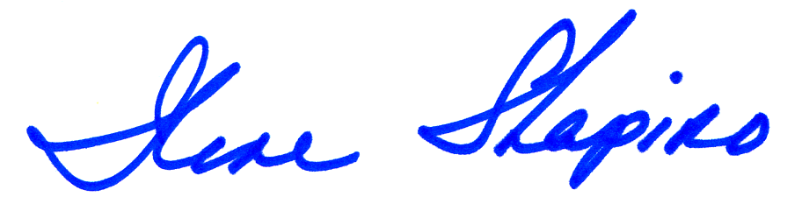

Ilene Shapiro, Executive
County of Summit

